**West, Rebecca (1892- 1983)**

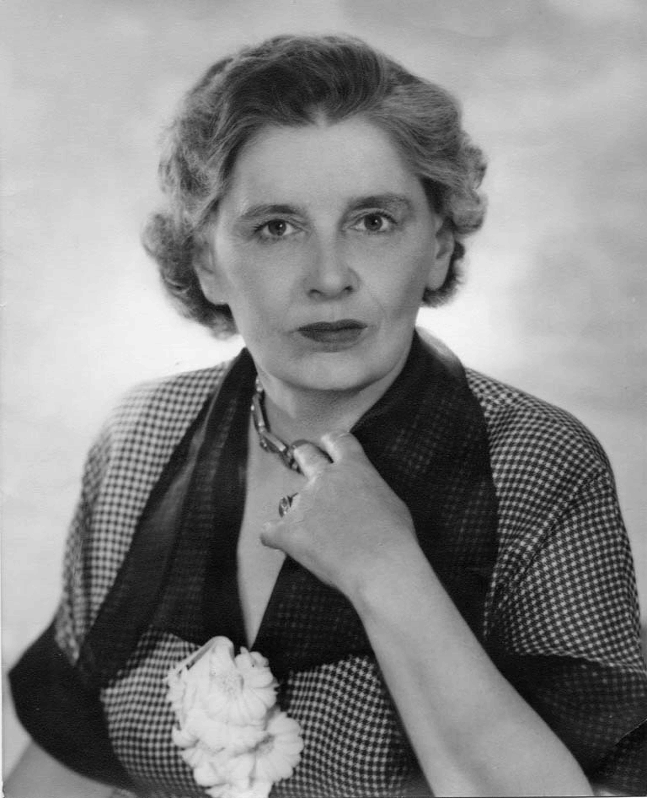SUMMARY

Rebecca West

url: <http://commons.wikimedia.org/wiki/File:Rebecca_West.jpg>

Rebecca West was a novelist, journalist, essayist and travel-writer, and a central figure in twentieth-century literary and political culture. Her *The Return of the Soldier* (1918) was the first World War One novel to be written by a woman. She was in her lifetime particularly celebrated for her travel writing, notably *Black Lamb and Grey Falcon* (1941), and her coverage of the Nuremberg trials for *The New Yorker*, published as *A Train of Powder* in 1955. *Time* magazine called her ‘indisputably the world's number one woman writer’ in 1947.

MAIN ENTRY

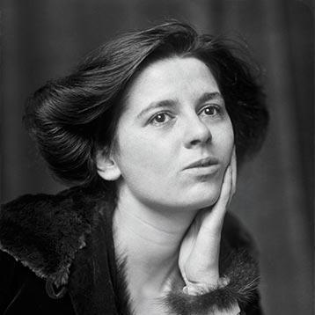Rebecca West (born Cicely Isabel Fairfield) and her two older sisters were brought up by their mother in London and Edinburgh, having been abandoned by their father when she was eight years old. Her political interests were evident from a young age; her first publication was a letter written to *The Scotsman* when she was just 14, defending the suffragist National Women’s Social and Political Union (she was later to publish an appreciation of Emmeline Pankhurst, ‘A Reed of Steel’, in 1933). In young adulthood she supported herself through her journalism while training as an actress, taking the nom de plume Rebecca West from the freethinking heroine of Henrik Ibsen’s *Rosmersholm* (although she later distanced herself from both the play and the character). While Virginia Woolf notes in *A Room of One’s Own* (1929) that West was labelled an ‘arrant feminist,’ West had famously averred in her 1913 essay ‘Mr. Chesterton in Hysterics’ that ‘I myself have never been able to find out what feminism is; I only know that people call me a feminist whenever I express sentiments that differentiate me from a doormat or a prostitute.’ She became assistant editor of the suffragist publication *The Freewoman* in 1914, playing a key role in its transformation into *The Egoist*, one of the foremost outlets for avant-garde literature and literary criticism in the period.

Rebecca West as a young woman

url: <http://www.tnr.com/book/reviews/biography>

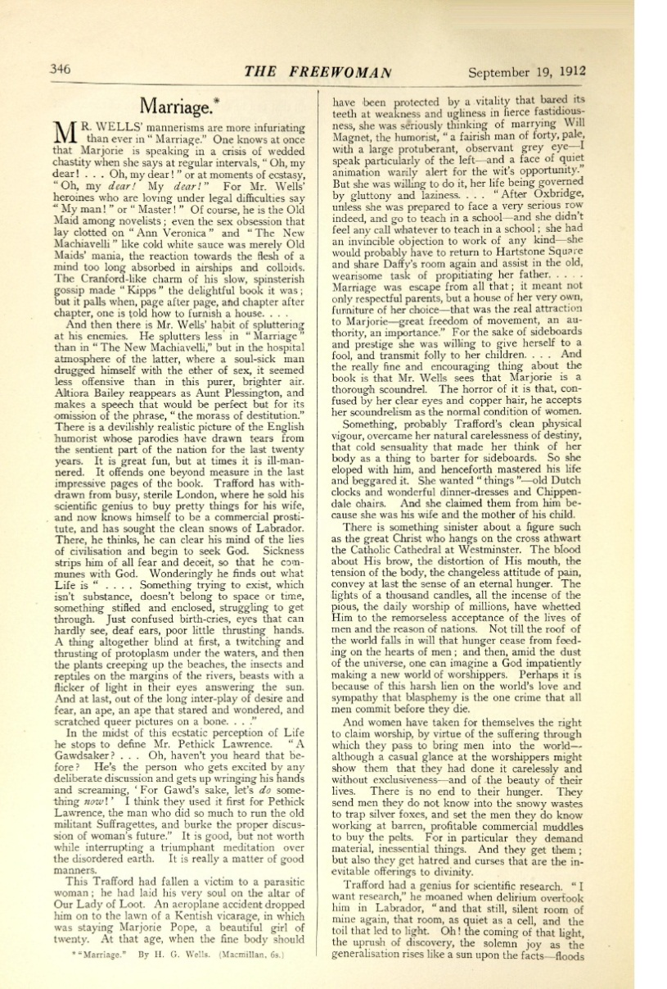

The first page of West’s controversial 1912 review of H. G. Wells’s novel *Marriage,* in *The Freewoman*. Wells was so provoked that he invited West to lunch; they began an affair that was to last a decade.

url: <http://dl.lib.brown.edu/pdfs/1302281169451379.pdf>

This item might be better as a pop-out so that it can be large enough for the type to be legible.

West’s literary and journalistic output was extensive and wide-ranging. Her best known work of fiction remains her first novel *The Return of the Soldier*, written when she was 24 and published when she was 26. While with less explicit political heft than some of her later work, it nevertheless carries a powerful indictment of war, telling the story of a shell-shocked officer returning from the war. Indeed, it was one of the earliest literary texts to address this newly identified psychological condition. It is still regarded as one of the most important literary responses to World War One, particularly ground breaking in terms of its investigation of the effect of war on the women of the home front.

West’s early fiction displays to a varying degree recognisably modernist characteristics and preoccupations, including explorations of Freudian themes and sexual relations, and experimentation with narrative perspective and form. West’s earliest known fiction, an unfinished novel called *The Sentinel* (written 1909-11; published 2002) is striking in its descriptions of the ill-treatment and force-feeding of imprisoned suffrage campaigners. Her first published work of fiction was a short story called ‘Indissoluble Matrimony,’ published in the Vorticist Journal *BLAST* in 1914 and offering an indictment of the constraints that marriage puts upon a sexually and politically active central female character. Her next novel after *Return of the Soldier*, *The Judge* (1922) continues these themes of women’s desire for sexual freedom and political agency, focussing on gender politics in the context of the women’s suffrage movement. Her 1929 novel *Harriet Hume* is subtitled ‘A London Fantasy,’ signalling its exploration of the mystical (its protagonist develops the ability to read her lover’s mind) as well as its metropolitan setting.

West later embarked on a series of semi-autobiographical novels known as the Aubrey trilogy, although only the first of these was published during her lifetime. She also wrote a spy thriller, *The Birds Fall Down*, published in 1966. In addition, she was a significant literary critic: she wrote a monograph on Henry James in 1916 and contributed hundreds of reviews and literary critical essays to newspapers and periodicals throughout her career.

An avid traveller throughout her life, West’s reputation as a travel writer became firmly established with her three-volume *Black Lamb and Grey Falcon* (1941). Based on her visits to the then Yugoslavia in the late 1930s, this work is now widely regarded as a classic of the genre. Aside from *Black Lamb* *and Grey Falcon*, West’s most extensive travel writing was about her long stays in Mexico in 1966 and 1969, although again this work was only published after her death. She was particularly fascinated by the United States, building a reputation on both sides of the Atlantic; in 1948 she was awarded the Women’s Press Club Award for Journalism by President Harry Truman, who called her ‘the world’s best reporter’. She remained intensely politically engaged throughout her life, visiting South Africa to report on apartheid for the *Sunday Times* in 1960, and continued publishing right up until her death in 1983.

**‘Goodness Doesn’t Just Happen’; West’s 1952 contribution to *This I Believe*, a regular 5-minute CBS radio feature.**

url: <http://thisibelieve.org/essay/17089/> I have been unable to download the audio file for this, though it can be purchased from Amazon, but it is freely available on the website given.

### Selected list of works

**Fiction**

*The Return of the Soldier* (1918)

*The Judge* (1922)

*Harriet Hume* (1929)

*The Harsh Voice: Four Short Novels* (1935)

*The Fountain Overflows* (1956)

*The Birds Fall Down* (1966)

*This Real Night* (1984)

*Cousin Rosamund* (1985)

*The Sentinel* (2002)

**Non-fiction**

*Henry James* (1916)

*The Strange Necessity: Essays and Reviews* (1928)

*St. Augustine* (1933), first psycho-biography of the Christian Church Father

*Black Lamb and Grey Falcon* (1941)

*The Meaning of Treason* (1949)

*A Train of Powder* (1955)

*The Court and the Castle: some treatments of a recurring theme* (1958)

*1900* (1982)

*Survivors in Mexico* (2003)

### Further reading

Glendinning*,* Victoria (1987) *Rebecca West: A Life*, London: Weidenfeld & Nicolson

Norton*,* Ann V. (2000) *Paradoxical Feminism: The Novels of Rebecca West*, Bethesda, MD: International Scholars Publications.

Rollyson,Carl (1998) *The Literary Legacy of Rebecca West*, Bethesda, MD: International Scholars Publications.

Schweizer, Bernard (ed) (2006) *Rebecca West Today: Contemporary Critical Approaches,* Newark, DE: University of Delaware Press.

Wolfe, Peter (1971) *Rebecca West: Artist and Thinker,* Carbondale: Southern Illinois University Press.

**Bryony Randall, University of Glasgow**